Section 1

1101 + 1001 = 10110
num1 = 8'b;
num2 = 8'b11011001;
- Verilog (dataflow mode)
- RTL scheme
- Testbench
- Simulation output

module topl4bit(in1,in2,out1);
input [3:0] in1,in2;
output [4:0] out1;
assign out1 = in1 + in2;
endmodule
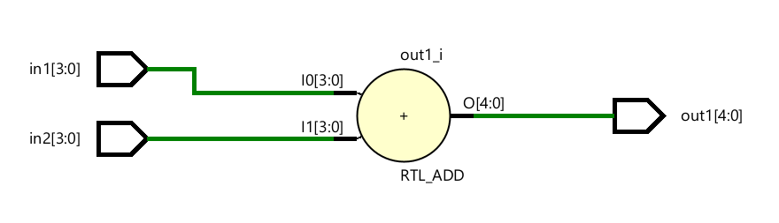
module topl4bit_tb();
reg [3:0] num1,num2;
wire [4:0] res1;
topl4bit UUT(.in1(num1),.in2(num2),.out1(res1));
initial begin
num1 = 4'b1101;
num2 = 4'b1001;
#100;
end
endmodule

Section 2

00011001 - 11011001 = 01000000

- Verilog (dataflow mode)
- RTL scheme
- Testbench
- Simulation output

module subsub(in1,in2,out1);
input [7:0] in1,in2;
output [7:0] out1;
assign out1 = in1-in2;
endmodule
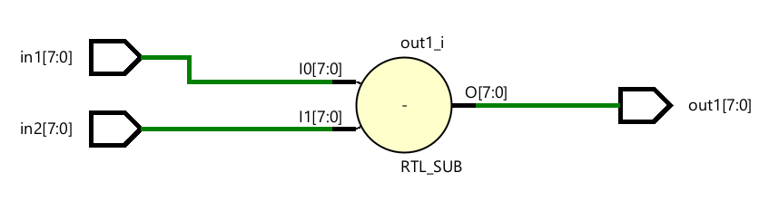
module subsub_tb();
reg [7:0] num1,num2;
wire [7:0] res1;
subsub UUT(.in1(num1),.in2(num2),.out1(res1));
initial begin
num1 = 8'b00011001;
num2 = 8'b11011001;
#100;
end
endmodule

Section 3
11011 x 1101011 = ? (107x27=?) <use exact bit numbers>
- Verilog (dataflow mode)
- RTL scheme
- Testbench
- Simulation output

module topl4bit(in1,in2,out1);
input [4:0] in1;
input [6:0] in2;
output [11:0] out1;
assign out1 = in1 * in2;
endmodule
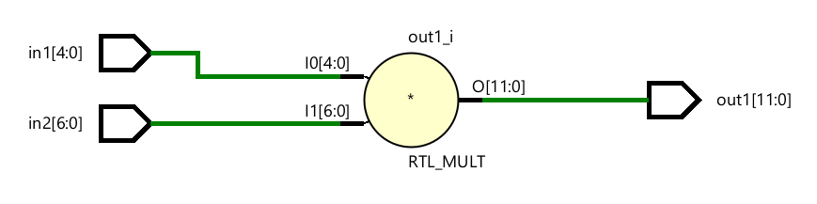
module topl4bit_tb();
reg [4:0] num1;
reg [6:0] num2;
wire [11:0] res1;
topl4bit UUT(.in1(num1),.in2(num2),.out1(res1));
initial begin
num1 = 5'b11011;
num2 = 7'b1101011;
#100;
end
endmodule

